**Automated multi-well spheroid targeting and dynamic OCT-based assessment for 3D in vitro imaging**

Rameesa Rafi M H*a, Ibrahim Abd El-Sadeka,b, Rion Morishitaa, Shadil Basheera, Atsuko Furukawac, Shuichi Makitaa, and Yoshiaki Yasunoa

*aComputational Optics Group, University of Tsukuba, Japan. bDepartment of Physics, Faculty of Science, Damietta University, Egypt. cClinical Research and Regional Innovation, Faculty of Medicine, University of Tsukuba, Japan*

**Keywords:** High-throughput imaging, dynamic optical coherence tomography, spheroid, automated sample targeting.

**Note: 3-page abstract can be found on the next page.**

**100-word abstract**

We present an automated sample targeting system (ASTS) for high-throughput, label-free imaging of 3D tumor spheroids using Jones matrix-based OCT. By integrating a motorized stage with synchronized OCT acquisition via TCP communication, the system enables fully automated imaging across a 96-well plate. It successfully targeted and imaged 15 tumor spheroids without any manual intervention. Functional imaging modalities such as LIV and OCDS were used to capture both structural and dynamic contrasts. Limitations including out-of-focus and out-of-field-of-view (FOV) spheroids, were observed, which highlights the need for future implementation of vertical axis control to improve spheroid localization and imaging accuracy.

**250-word abstract**

High-throughput, label-free imaging of 3D tumor spheroids is critical for accelerating biomedical research and drug discovery. However, conventional Jones matrix-based dynamic optical coherence tomography (OCT), though powerful for extracting both structural and functional information, remains limited by its manual operation, which makes the imaging process time-consuming and operator-dependent. To overcome this bottleneck, we propose an automated sample targeting system (ASTS) that integrates a motorized linear stage into the Jones matrix OCT platform. The system is controlled using a custom Python interface and enables fully automated, sequential imaging of multiple samples within a standard 96-well plate.

Using a two-dimensional linear translational stage and a brushless DC servo motor controller (BBD302), the system executes homing, precise jogging, and scanning steps via pre-calibrated well coordinates. The stage synchronizes with OCT acquisition through TCP communication, and assures reliable sample positioning without human intervention. We demonstrate the application of ASTS by targeting and imaging 15 MCF-7 breast cancer spheroids. Among these, 13 spheroids were successfully imaged; two showed imaging failures due to being out of focus or out of the field of view (FOV). These limitations are attributed to the 3D morphology of spheroids and their variable vertical positions in the well.

Functional OCT contrasts, such as logarithmic intensity variance (LIV) and OCT correlation decay speed (OCDS*l*), were acquired to provide dynamic activity maps. The system significantly improves imaging throughput and objectivity. The challenges encountered emphasize the need for future integration of vertical (Z-axis) control to enhance the reliability and precision of spheroid localization.

**Automated multi-well spheroid targeting and dynamic OCT-based assessment for 3D in vitro imaging**

Rameesa Rafi M H*a, Ibrahim Abd El-Sadeka,b, Rion Morishitaa, Shadil Basheera, Atsuko Furukawac, Shuichi Makitaa, and Yoshiaki Yasunoa

*aComputational Optics Group, University of Tsukuba, Japan. bDepartment of Physics, Faculty of Science, Damietta University, Egypt. cClinical Research and Regional Innovation, Faculty of Medicine, University of Tsukuba, Japan*

**Keywords:** High-throughput imaging, dynamic optical coherence tomography, tumor spheroid, automated sample targeting.

# INTRODUCTION

High-throughput imaging is essential for efficient and reproducible analysis of biological samples in biomedical research and drug screening. It enables rapid and accurate assessment of biological samples for various applications, including disease modelling and therapeutic testing[1]. Image-based, quick, and effective sample screening is a bottleneck of biomedical research[2,3]. Jones-matrix-based dynamic optical coherence tomography (OCT) potentially can be the basis for image-based high-throughput screening and is particularly valuable for studying spheroids, organoids, and other *in vitro* models, but its measurement procedure is elaborate and still relies on manual control of the sample container (i.e., well plate). Hence, it leads to significant limitations such as frequent sample repositioning, long screening time, which compromises the sample viability.

In this presentation, we propose an XY-translational stage controlled “automated sample targeting system(ASTS)”, which is a fast, automated, and objective quantification platform designed to automatically locate in vitro samples within a 96-well plate and perform successive OCT scans. The system was applied to image human breast adenocarcinoma spheroids (MCF-7 cell line) positioned in designated wells of the 96-well plate.

# METHOD

### Initialization and setup

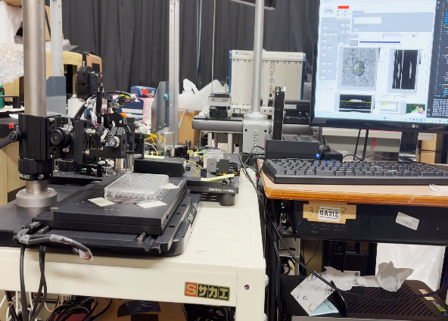

Fig 1: ASTS integrated in JM-OCT system

We integrated a motorized linear stage platform (MLS203-1, Thorlabs Inc., USA) driven by a brushless DC servo motor controller (BBD302, Thorlabs Inc., USA) into the Jones matrix OCT system. A custom Python program is used to control the stage movement, beginning with homing (moving the motorized stage to a predefined reference position), followed by jogging (small, incremental movements for precise positioning). As the next step, the standard 96-well plate, which is arranged in an 8×12 grid, is optimised for coordinate distribution, such that the rows(labelled A-H) and columns (labelled 1-12) correspond to the coordinates where the stage is intended to move (see Fig. 2). In this coordinate distribution, a 9 mm increment is distributed to both the rows and columns of the well plate. This is because the distance from the centre of one well to the adjacent well

is 9mm, so that the stage can move in a controlled manner throughout the scanning time, and can efficiently target each well.

### Synchronizing the stage control and automated OCT acquisition

The motorized stage, which is controlled via Python, and the OCT system, operated through LabVIEW, were integrated using a TCP communication protocol of LabVIEW. This architecture ensures coordinated movement of the stage and timely image acquisition without manual intervention. In this setup, the Python script functions as the master by sending TCP signals to LabVIEW to trigger OCT image acquisition after positioning the stage at each well. LabVIEW, functioning as the acquisition client, waits for incoming commands and performs acquisition accordingly. Once the acquisition of one well is completed, the Python program monitors the file size until it stabilizes, save the data, and then moves the stage to the next well for further acquisition. In this way, automated sequential imaging of the 96-well plate is achieved and fully eliminates the manual interventions and ensures precise timing between jogging and acquisition.

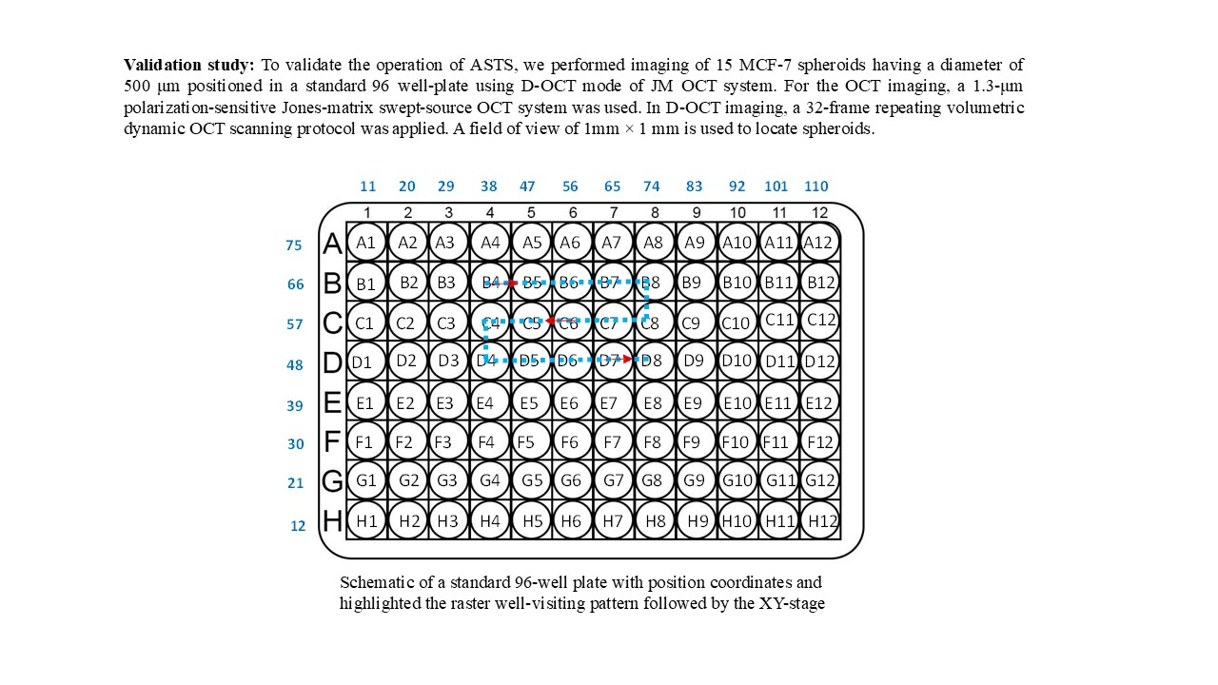

### Sample preparation and validation study

The operation of ASTS is validated by imaging 15 MCF-7 spheroid samples having a size of 500 μm. Human breast-derived tumor cells have been seeded in a 96-well ultra-low attachment plate to form the tumor spheroid [4]. 1,000 cells per well were cultured to form the 3D tumor spheroid. By the 6th day, spheroids had fully formed in all the wells and were kept in predefined well positions of the well plate as defined in the Python program.

The Python-controlled X-Y translation stage follows a raster well-visiting scanning(fig.2) starting from B4 (the first position containing spheroids) up to D8 (the last position) by completing the acquisition across all the wells

Fig 2: Schematic of a standard 96-well plate with position coordinates and highlighted the raster well-visiting pattern followed by the XY-stage

.

### OCT scanning protocol

A 1.3-μm swept-source OCT device, operating at a speed of 50,000 A-lines/s, is used for imaging. The objective used was LSM03 (Thorlabs), which has an effective focal length of 36 mm and provides a lateral resolution of 18.1 μm. For DOCT imaging, a lateral imaging field of 1 × 1 mm2 was set, and a 4-block repeating scanning protocol was used, and each block consists of 32 B-scan locations. Each block was raster scanned 32 times in 6.55 s. Hence, at each B-scan location, 32 repeated frames were captured with an inter-frame interval of 204.8 ms. The OCT volume comprising 128 locations was captured in 26.4 seconds for each sample.

# RESULTS AND DISCUSSION

Fig 3: MCF-7 spheroid dynamic imaging. The panel includes bright field, Cross-section, OCT Intensity, LIV, and OCDS *En face* images of 15 MCF-7 spheroids acquired automatically. The spheroids that were out of focus or out of the field of view (FOV) are highlighted in the figure.

Out of the 15 spheroids targeted, 13 were successfully imaged using the automated system. The remaining two exhibited issues with being out of focus and out of the field of view. A key limitation observed during automated imaging was the difficulty in consistently achieving precise focus and accurate localization of spheroids within the imaging field. This challenge is primarily due to the three-dimensional nature of spheroids, which do not always settle at a uniform depth within the wells. Moreover, variations in liquid volume between wells can cause shifts in both depth and lateral position, which further complicates the automated acquisition process.

To assess cellular dynamics, two types of label-free contrast images were generated from time-series OCT intensity frames using two algorithms: logarithmic-intensity variance (LIV) and OCT correlation decay speed (OCDS*l*). The LIV maps provided motion contrast, while OCDS offered insights into intracellular activity. Notably, the central regions of all the spheroids exhibited reduced OCDS signals, indicative of necrotic cell death likely caused by hypoxia and limited nutrient availability, which is common in the core of cancer spheroids.

### Importance of the proposed system.

The proposed system enables automated, image-based assessment of spheroids and serves as a powerful tool for evaluating drug effects over multiple time points. By applying different anti-cancer drugs or the same drugs with different concentrations to spheroids and monitoring them using OCT at regular intervals over several days, this platform allows researchers to observe dynamic cellular responses in a label-free, non-invasive manner. Such time-resolved imaging can reveal which drug is most effective against a patient’s specific cancer cell model, and supports personalized treatment strategies.

# CONCLUSION

In this study, we developed and validated an automated sample targeting system (ASTS) for high-throughput, label-free imaging of 3D spheroid models using Jones-matrix-based OCT. The integration of a motorized stage with synchronized OCT acquisition via TCP communication enabled fully automated imaging of spheroids within a 96-well plate. The system successfully imaged 13 out of 15 spheroids with minimal manual intervention and demonstrated the reliability and efficiency of the automation pipeline. Despite challenges related to focusing and field-of-view alignment due to the 3D nature of spheroids, the platform successfully captured structural and functional contrast through LIV and OCDS imaging. These capabilities allow for non-invasive monitoring of drug responses at multiple time points and support image-based preclinical evaluation in a scalable manner. The proposed system not only improves the speed and reproducibility of OCT-based screening but also paves the way for personalized drug testing, bridging the gap between engineering tools and biomedical research.

Building on the limitations of the current system, future improvements can focus on integrating an additional depth-axis (Z-axis) manipulator to the OCT imaging probe and establishing an image-based feedback mechanism. This would enable precise three-dimensional positioning of the sample within the imaging field, thereby ensuring optimal focus and accurate localization of the spheroid during automated scanning.

# REFERENCES

[1] S.Pi et.al., *Opt. Lett.* **49**, 4481 (2024) [2] V. Lob *et al*., Med. Biol. Eng. Comput. **45**, 1023 (2007) [3] T. Geisler *et al*., IEEE Trans. Autom. Sci. Eng. **3**, 169 (2006). [4] I. A. El-Sadek et.al., Biomed. Opt. Express **12**, 6844–6862 (2021).